Remote Viewing within a High Voltage Apparatus

Blake Bagley, Julia Garcia, Erica Mathew

**Interface Control Document**

REVISION – Draft

26 September 2024

Interface Control Document

for

Remote Viewing within a High Voltage Apparatus

Prepared by:

_____________________________

Author Date

Approved by:

_____________________________

Project Leader Date

_____________________________

John Lusher II, P.E. Date

_____________________________

T/A Date

**Change Record**

| **Rev.** | **Date** | **Originator** | **Approvals** | **Description** |
| --- | --- | --- | --- | --- |
| **-** | 9/26/2024 | Blake Bagley, Julia Garcia, Erica Mathew |  | Draft Release |

**Table of Contents**

**Table of Contents III**

**List of Tables IV**

**List of Figures V**

**1.** **Overview 6**

**2.** **References and Definitions 6**

2.1. References 6

2.2. Definitions 6

2.3. Referenced Documents and Standards 6

**3.** **Physical Interface 6**

3.1. Weight 6

3.2. Dimensions 7

3.3. Mounting Locations 7

**4.** **Thermal Interface 7**

**5.** **Electrical Interface 8**

5.1. Primary Input Power 8

5.2. Voltage and Current Levels 8

5.3. Data Interfaces 9

5.4. User Control Interface 9

**6. Communication/Device Interface** **9**

6.1. Wireless Communications 9

**List of Tables**

Table 1: Printed Circuit Board Weight……………………………………………………………..5

Table 2: Printed Circuit Board Dimensions………………………………………………………..6

Table 3: Maximum Voltage, Current and Power Levels………………………………………….7

Table 4: Nominal Voltage, Current and Power Levels…………………………………………...8

**List of Figures**

Figure 1: Electrical Interface Diagram………………………………………………………7

# 1. Overview

This document is provided to detail how the thermal sensor will interface with the microcontroller and how the microcontroller will interface with the website. It will list all inputs, outputs, and how the system manages each. An explanation of the inputs from the thermal sensor to the microcontroller will be provided. Then, an explanation of how that input will be transferred from the microcontroller to the website will follow.

# 2. References and Definitions

## 2.1. References

Refer to section 2.2 of the Functional System Requirements document.

## 2.2. Definitions

mA Milliamp

mW Milliwatt

g Grams

mm Millimeters

V Volts

TBD To Be Determined

# 3. Physical Interface

## 3.1. Weight

**3.1.1. Entire Printed Circuit Board**

| **Component** | **Weight** | **Number of Items** | **Total Weight** |
| --- | --- | --- | --- |
| FLIR Lepton 3.5 Thermal Sensor | 0.91 g | 1 | 0.91 g |
| ESP32-S3 | TBD | 1 | TBD |
| Buck Converter Circuitry | TBD | 4 | TBD |

Table 1: Printed Circuit Board Weight

## 3.2. Dimensions

### 3.2.1. Dimensions of Entire Printed Circuit Board

| **Component** | **Length** | **Width** | **Height** |
| --- | --- | --- | --- |
| FLIR Lepton 3.5 Thermal Sensor | 12.7 mm | 11.5 mm | 6.835 mm |
| ESP32-S3 | 7 mm | 7 mm | 0.85 mm |
| Buck Converter Circuitry | TBD | TBD | TBD |

Table 2: Printed Circuit Board Dimensions

## 3.3. Mounting Locations

The thermal sensor will be mounted facing the grounding switch at the back of the switchgear. The sensor must face the grounding switch because the switch is being viewed by the operator. It can only fit in the back due to space constraints within the switchgear.

# 4. Thermal Interface

The ESP-32 microcontroller will use a heat sink in order to prevent overheating and decreased efficiency. There is only one microcontroller in our system, so only one heat sink is needed. The thermal sensor has safeguards in place to prevent overheating.

# 5. Electrical Interface

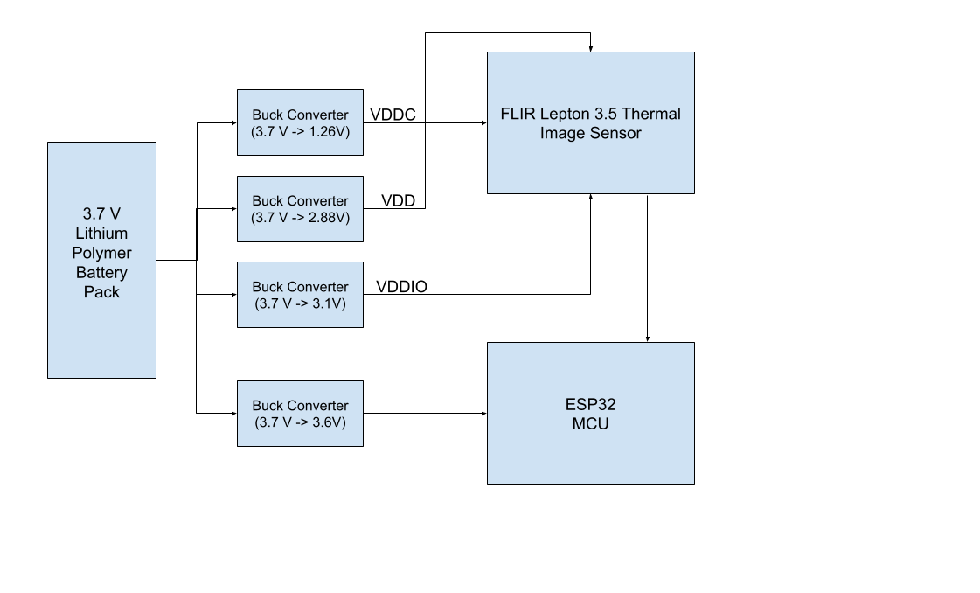

Figure 1: Electrical Interface Diagram

## 5.1. Primary Input Power

The system will be battery powered using a rechargeable 3.7 V lithium-ion polymer battery. When implemented into the switchgear, the system will be powered by the switchgear itself.

## 5.2. Voltage and Current Levels

### 5.2.1. Maximum Values

| Component | Voltage [V] | Current [mA] | Power [mW] |
| --- | --- | --- | --- |
| FLIR Lepton 3.5 Thermal Sensor | 4.8 | 16 | 76.8 |
| FLIR Lepton 3.5 Thermal Sensor Core | 1.5 | 110 | 165 |
| FLIR Lepton 3.5 Thermal Sensor I/O | 4.8 | 310 | 1488 |
| ESP32-S3 | 3.6 | 1500 | 3600 |

Table 3: Maximum Voltage, Current and Power Levels

### 5.2.2. Nominal Values

| Component | Voltage [V] | Current [mA] | Power [mW] |
| --- | --- | --- | --- |
| FLIR Lepton 3.5 Thermal Sensor | 2.8 | 14 | 39.2 |
| FLIR Lepton 3.5 Thermal Sensor Core | 1.2 | 84 | 100.8 |
| FLIR Lepton 3.5 Thermal Sensor I/O | 3.1 | 235 | 728.5 |
| ESP32-S3 | 3.3 | 500 | 1650 |

Table 4: Nominal Voltage, Current, and Power Levels

## 5.3. Data Interfaces

The thermal sensor will send raw video data to the microcontroller through serial pins (SPI), both the sensor and microcontroller are mounted to the PCB.

## 5.4. User Control Interface

The user control interface is a website that communicates with the microcontroller. The user will login using credentials provided through their companies. Then, the user will be able to select what switchgear vertical tower will be viewed. The user can select the desired video stream from the overview page or the user can use the search bar to find their desired video stream.

# 6. Communications / Device Interface Protocols

## 6.1. Wireless Communications

### 6.1.1. Wi-Fi

The microcontroller has a built-in WiFi module using IEEE 802.11b/g/n standards. This connection will be used to stream live video to the operator’s website.